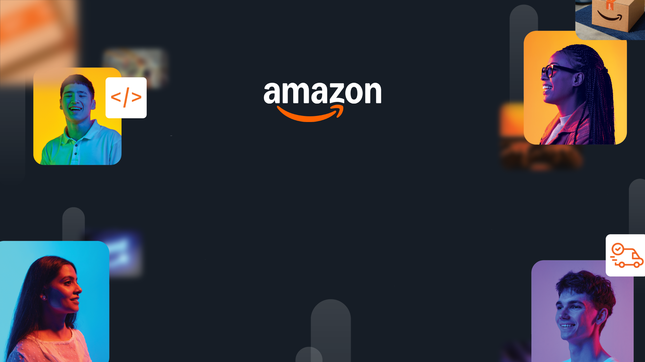

HackOn with Amazon
A Universe of Opportunity
48-Hour Hackathon | Solution Document

Team Name | icecream
Hackathon Theme | Second Life Commerce
Date | 15th June, 2026

Team Members
Name | College / University | Role | Email
Anupam Rawat | IIT Bombay |  | Anupam.rawat@iitb.ac.in
Arush Sharma | IIT Dhanbad |  | 23je0154@iitism.ac.in

1. Problem Statement & Relevance
→ Jury focus: Innovativeness (novelty, theme alignment) + Degree of Disruption (global relevance)

The Problem

Every year, a massive share of online purchases is returned, and a shocking fraction of those perfectly usable items is liquidated, downcycled, or landfilled because manually inspecting and routing each return costs more than the item is worth. The result is a triple loss: customers distrust refurbished goods, sellers eat reverse-logistics costs of up to 30–66% of an item's value, and the planet absorbs billions of pounds of avoidable waste. Returns today flow into a dumb reverse-logistics pipeline that has no idea what each item is actually worth or where it should go next.

Why It Matters
- Scale: Online return rates run ~20–30% overall and up to 30–40% for fashion; reverse logistics is a $600B+ global problem and a major source of e-commerce waste.
- Customer cost: Slow, opaque refunds and a deep trust gap on refurbished/second-hand items, buyers can't tell a Grade-A return from a damaged one.
- Seller cost: Returns are processed by hand; the cheapest path (liquidate/destroy) is chosen by default, destroying recoverable value.
- Planet cost: Usable goods are destroyed, wasting the carbon already spent manufacturing them.
- Cost of inaction: Returns volume grows with e-commerce; without intelligent triage, both the financial write-off and the environmental footprint scale linearly with growth.→ Tip: Show global scale. Problems affecting millions score higher than niche issues.

Theme Alignment

The theme asks for "an intelligent ecosystem where returned or unused products automatically find their next best owner." ReVival is that routing brain.
Our unique angle: we don't treat disposition as a classification ("is it damaged?") — we treat it as a value-and-carbon optimization problem solved per item in seconds, paired with a GenAI trust layer that makes refurbished products believable to buyers.

What Makes This Novel
- Disposition-as-optimization: instead of a yes/no "resaleable" flag, ReVival computes the expected net value of every possible second life (open-box resale, refurbish, P2P, donate, recycle, return-to-vendor) and routes to the argmax of economic value + carbon savings, under hard safety/hygiene constraints. To our knowledge no consumer-facing returns flow exposes this decision explicitly.
- The Condition Passport: a GenAI-generated, transparent certificate ("Grade B — minor scuff, fully functional, ~14 months expected life") + a buyer-facing Q&A agent. This attacks the single biggest blocker to resale — trust — head-on.
- Closed sustainability loop: carbon saved by each reuse decision is quantified and returned to the customer as Green Credits, turning sustainability into a measurable incentive rather than a slogan.

2. Customer & Solution
→ Jury focus: Quality of Presentation (clarity) + Quality of Implementation (working prototype)

Target Customer
[Who is your user? Describe the persona in 2-3 lines. What do they need?]

How We Solve It
[Describe your solution in plain language. What does it do? Key features (3-5 max):]
- [Feature 1]
- [Feature 2]
- [Feature 3]

User Workflow
[[Insert a simple diagram or 3-step flow showing how a user interacts with your solution]]
→ A clear visual here directly impacts your Presentation score.

Working Prototype
[[Insert 2-3 screenshots of your working product]]
Demo: [Video/Deployed URL]
→ End-to-end working prototype with evidence = highest Implementation score.

3. Tech Architecture & Scaling
→ Jury focus: Tech Architecture (complexity, algorithms, APIs, code quality) + Scalability (depth, interconnectedness)

Architecture
[[Insert system architecture diagram]]

Tech Stack
Layer | Technology | Why
Frontend | [e.g., React] | [Reason]
Backend | [e.g., FastAPI] | [Reason]
Data/ML | [e.g., DynamoDB, Bedrock] | [Reason]
Infra | [e.g., Lambda, S3] | [Reason]

Key Algorithms & Complexity
[What core algorithms power your solution? Describe complexity and why you chose this approach.]
→ Show thought leadership: novel combinations, creative use of algo/tech, not just standard CRUD.

Scaling Strategy
[How does this handle 100x-1000x growth? Describe horizontal scaling, caching, or distribution approach.]
→ Solutions restricted to local functionality score low. Show global scalability.

4. Future Vision
→ Jury focus: Futuristic Vision (long-term thinking, multi-segment expansion, value impact)

Where This Goes
[What does this become in 1-3 years? What is the big-picture vision?]

Roadmap
Horizon | Milestone | Impact
0-3 mo | [Near-term] | [Users/metrics]
3-6 mo | [Mid-term] | [Users/metrics]
6-12 mo | [Long-term] | [Users/metrics]

Multi-Segment Expansion
[Which other industries, markets, or user segments can this expand to? Describe the path.]
→ Showing clear multi-segment strategy (e.g., healthcare > education > logistics) scores highest.

Value Impact
[Quantify: How many users impacted? What cost savings, efficiency gains, or revenue potential at scale?]

Links: GitHub [URL] | Demo Video [URL] | Live App [URL]

